Name:Jeevan S U

**Name: Jeevan S U**

**Roll No: 241059038**

**Subject: Cryptology Lab**

**Program: M.E in Cyber Security, MSIS, MAHE**

1. Write a Python script to encrypt columnar transposition using keyword.

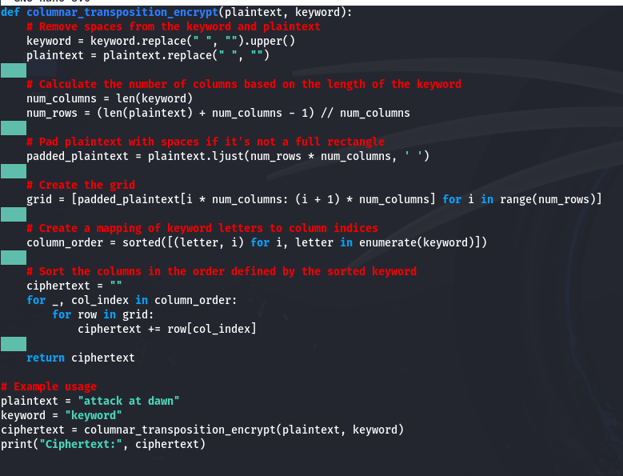

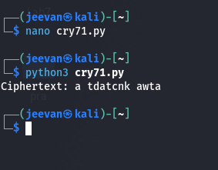

1. Write a Python script to encrypt double columnar transposition.

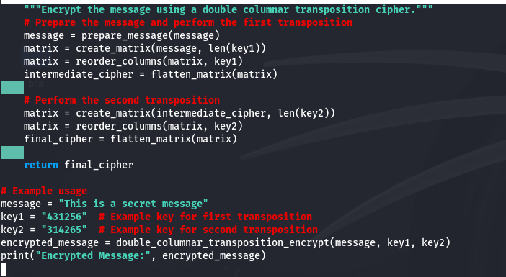

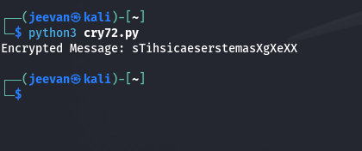

3. Write a Python script to encrypt the message “She is listening” using the 6-character keyword “PASCAL” with Vigenere cipher. 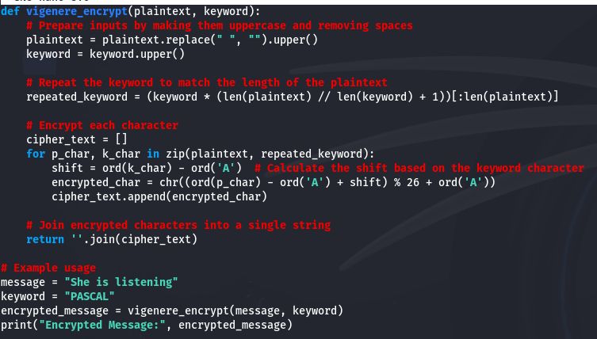

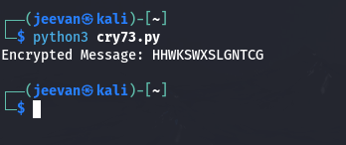

1. Write a Python script to perform Kasiski test.

